**Prerequisites**

**Software ( Python 3.6.5 )**

|  |  |
| --- | --- |
| Date | 01 november 2022 |
| Team ID | PNT2022TMID23204 |
| Project Name | Project - IoT based Safety Gadget for Child Safety Monitoring & Notification |
| Maximum Marks | 4 Marks |

**Safety Gadget for child safety Monitoring & Notification :**

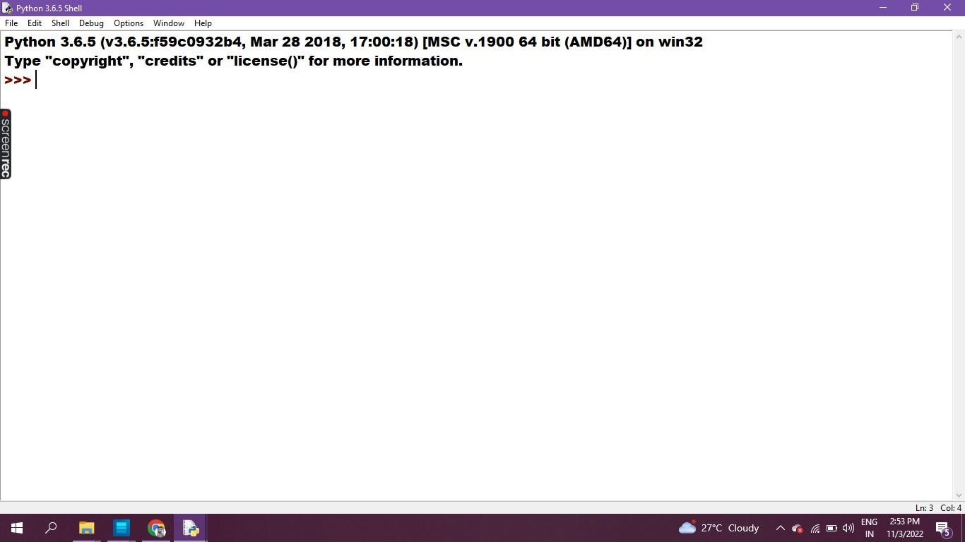

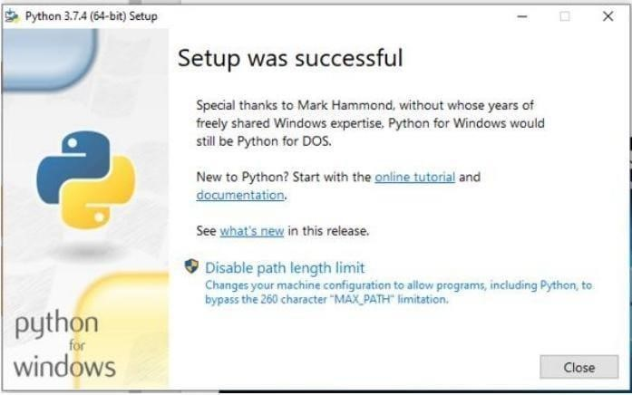

**Program & Output in Python IDLE 3.6.5 - 64bit**

